**UML Diagrams**

**MAIN PROJECT – 20MCA246**

**FarmConnect**

***Empowering Agricultural Commerce through Digital Platform***

1. **Use Case Diagram**

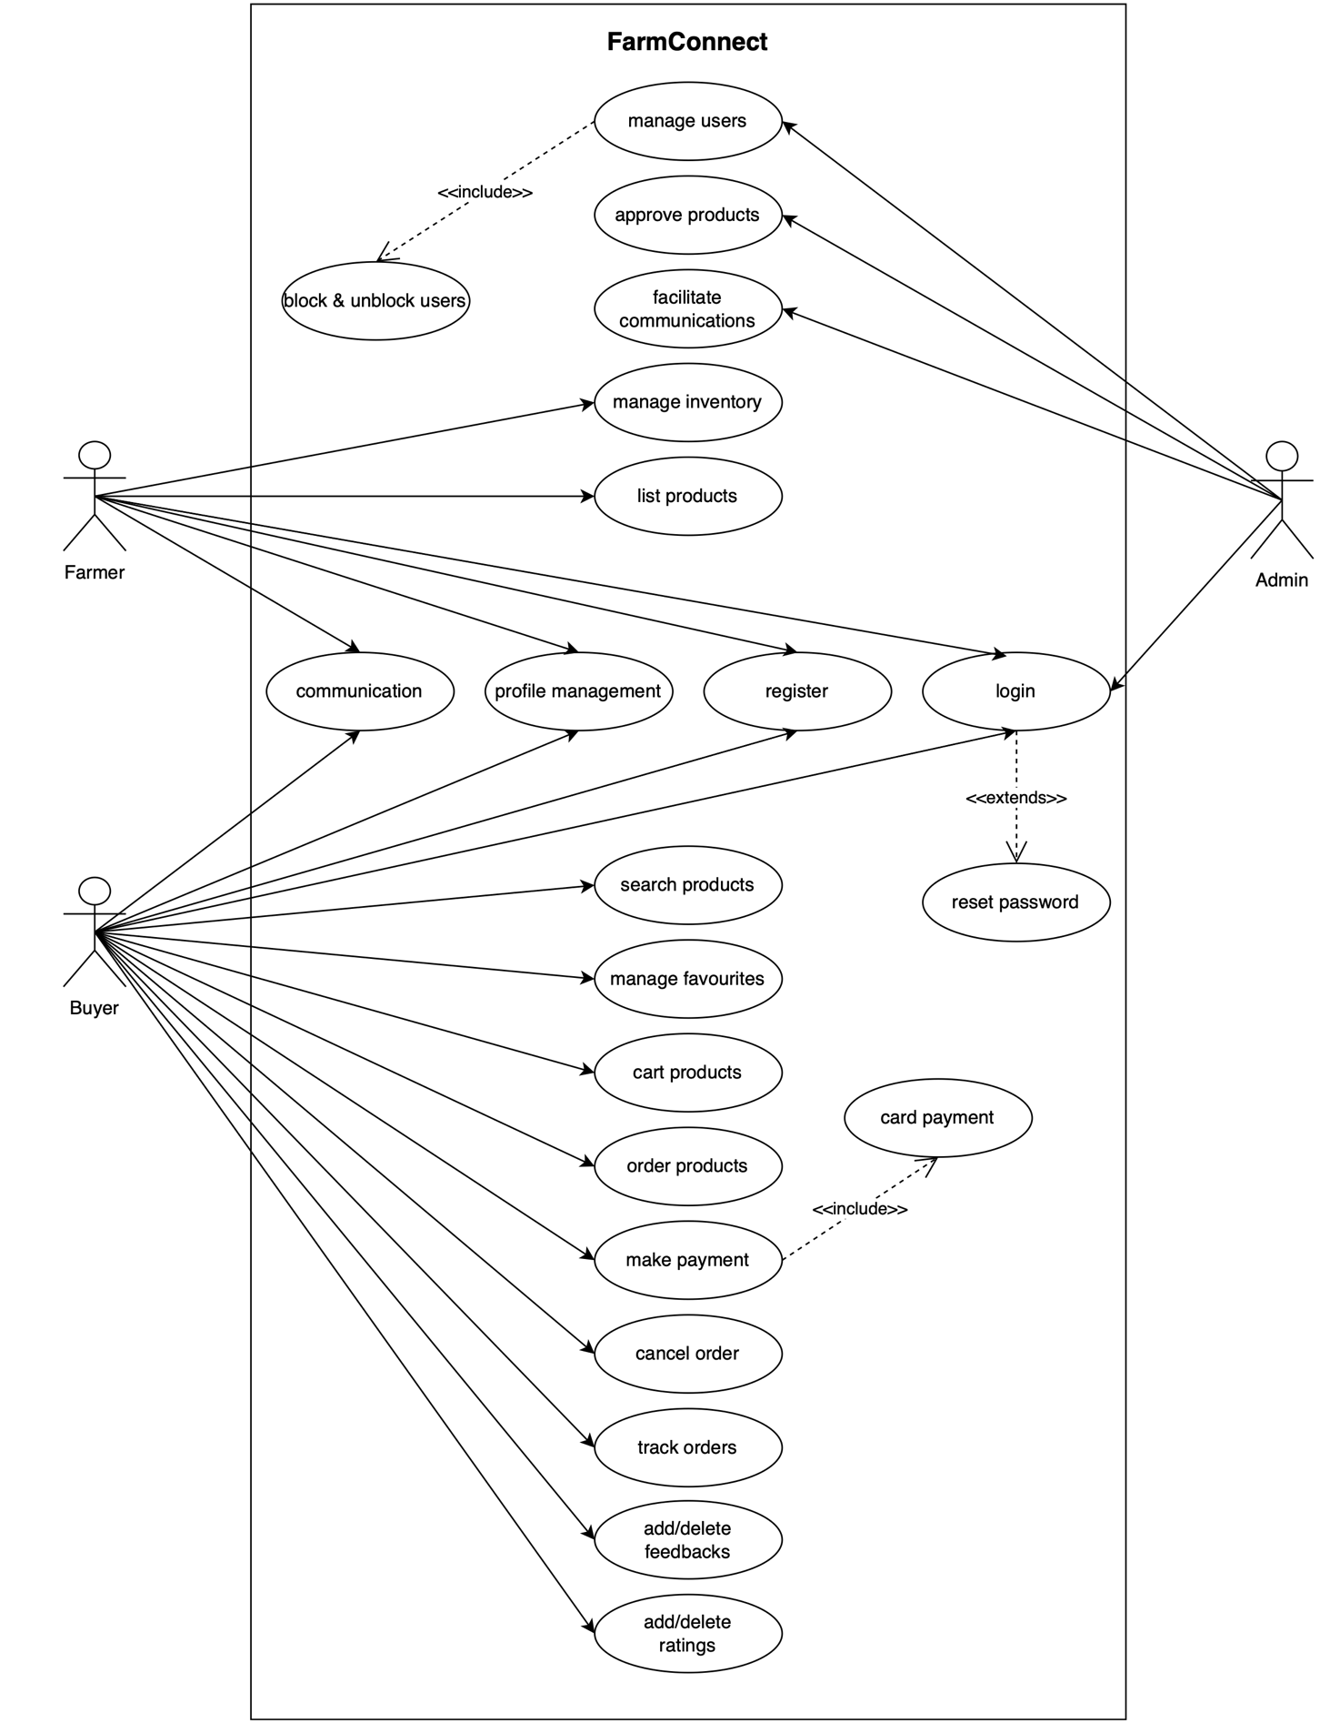

1. **Class Diagram**

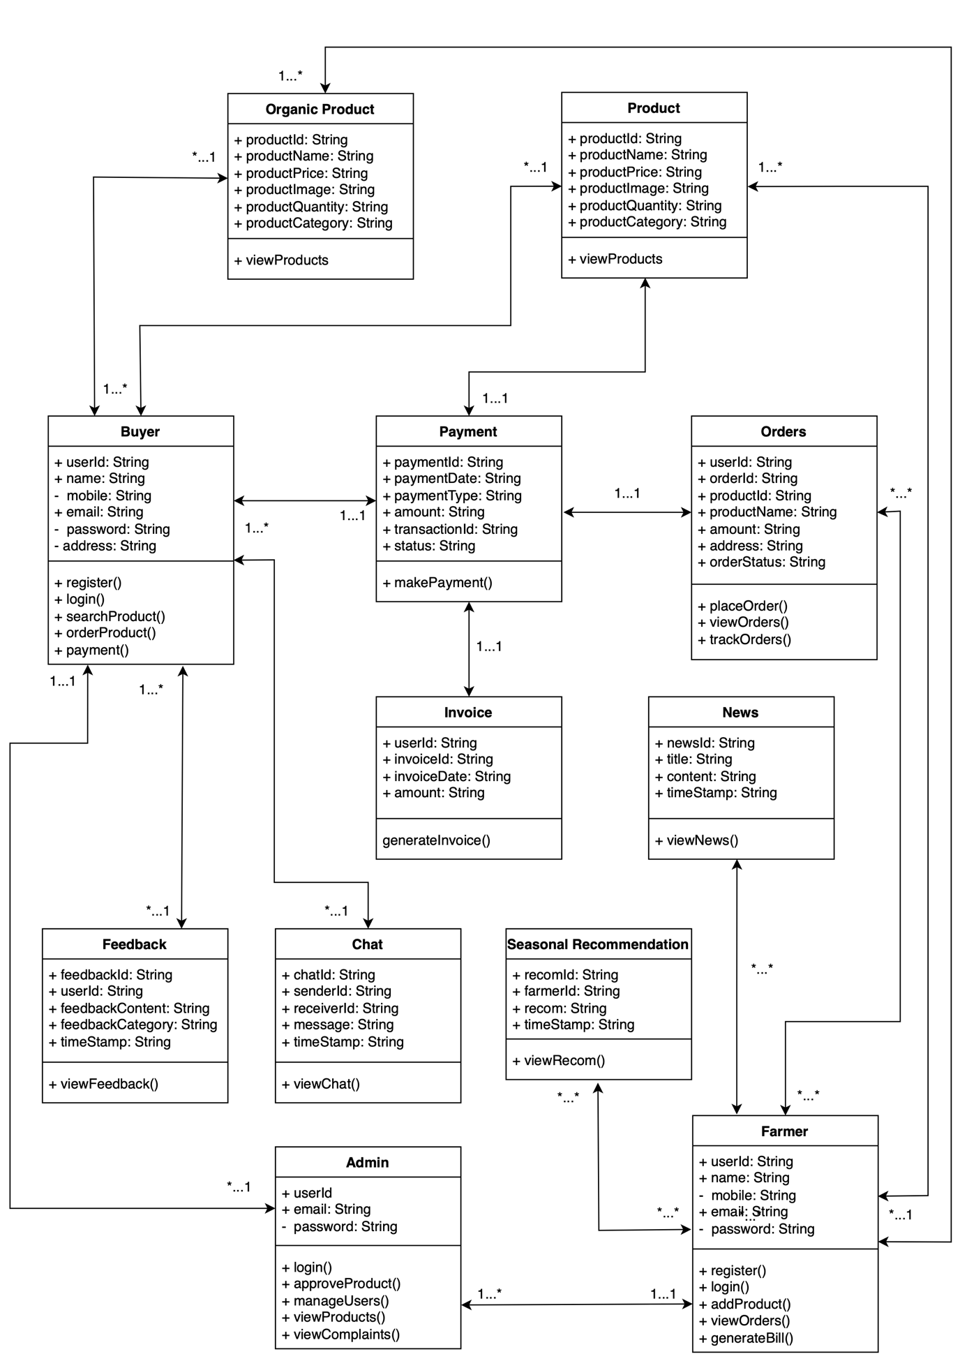

1. **Object Diagram**

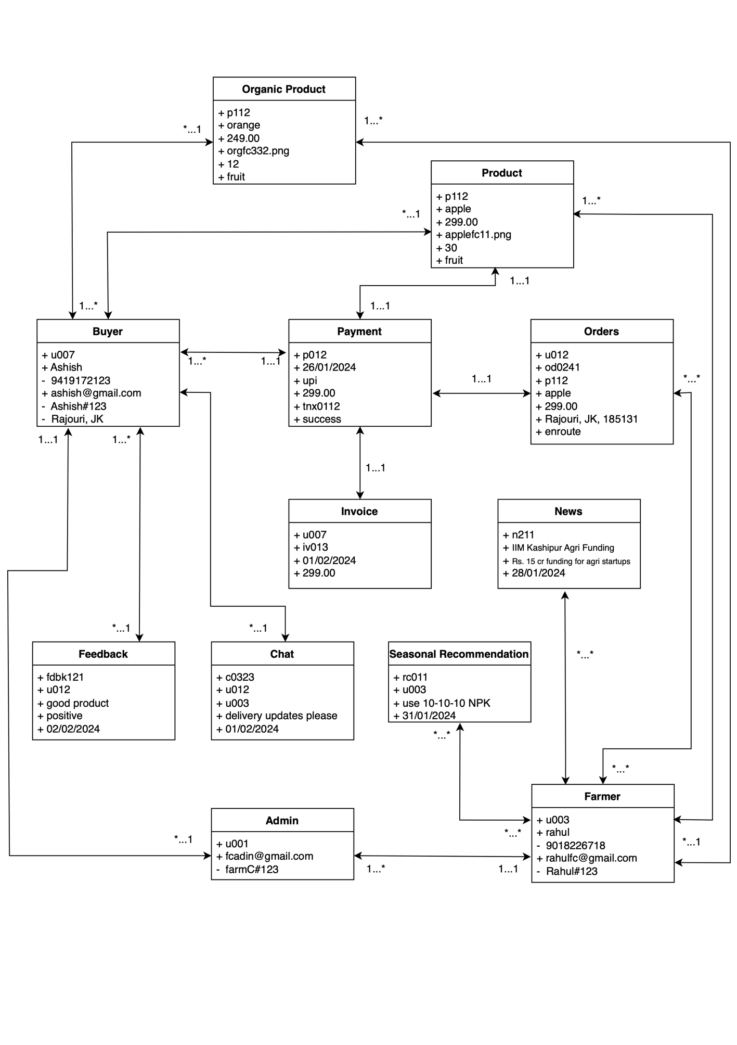

1. **Activity Diagram**

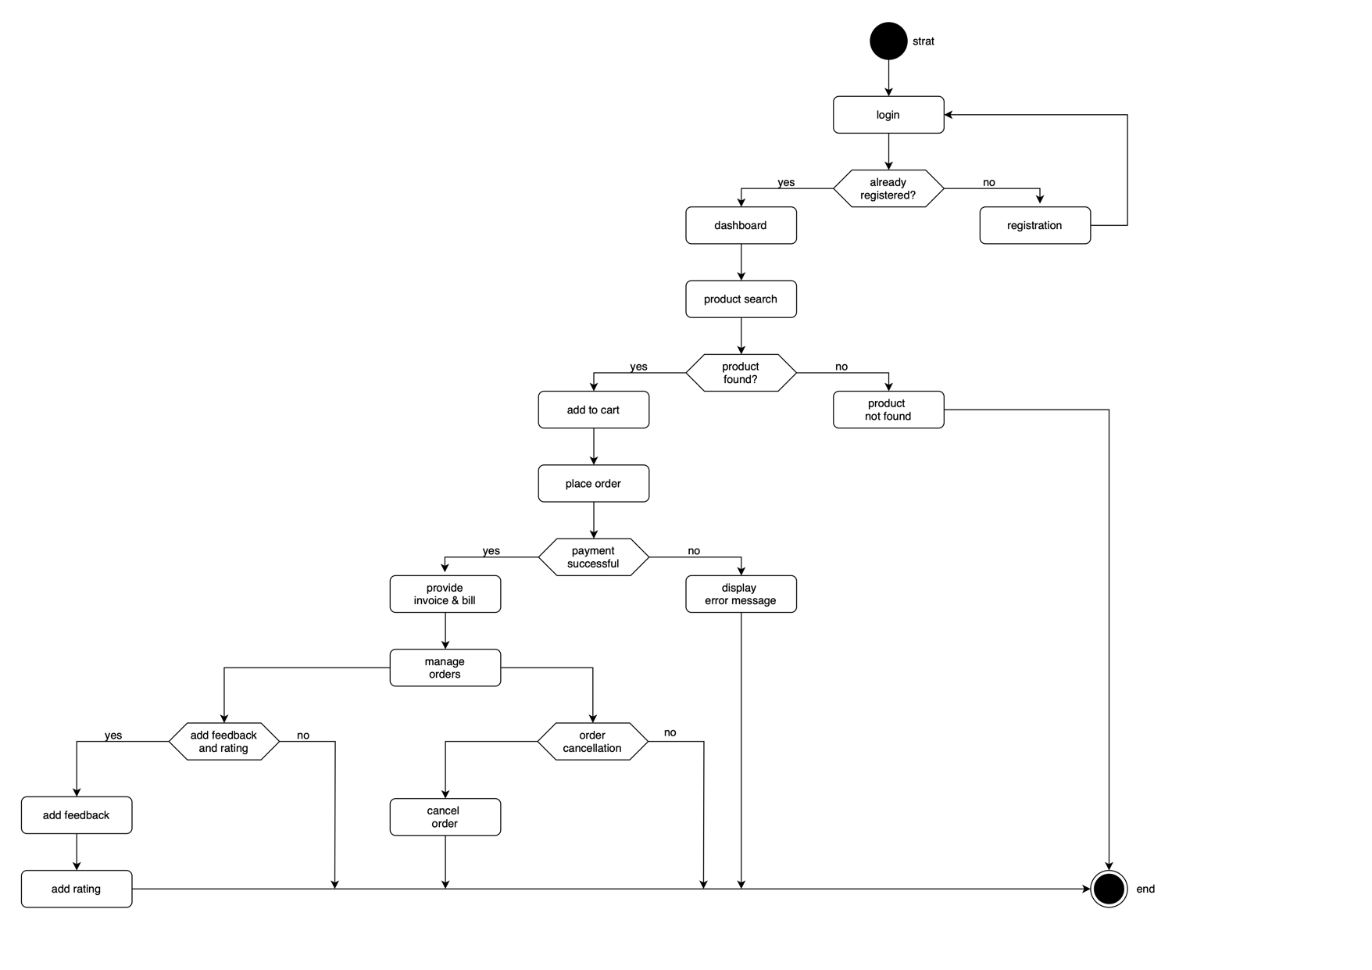

1. **Sequence Diagram**

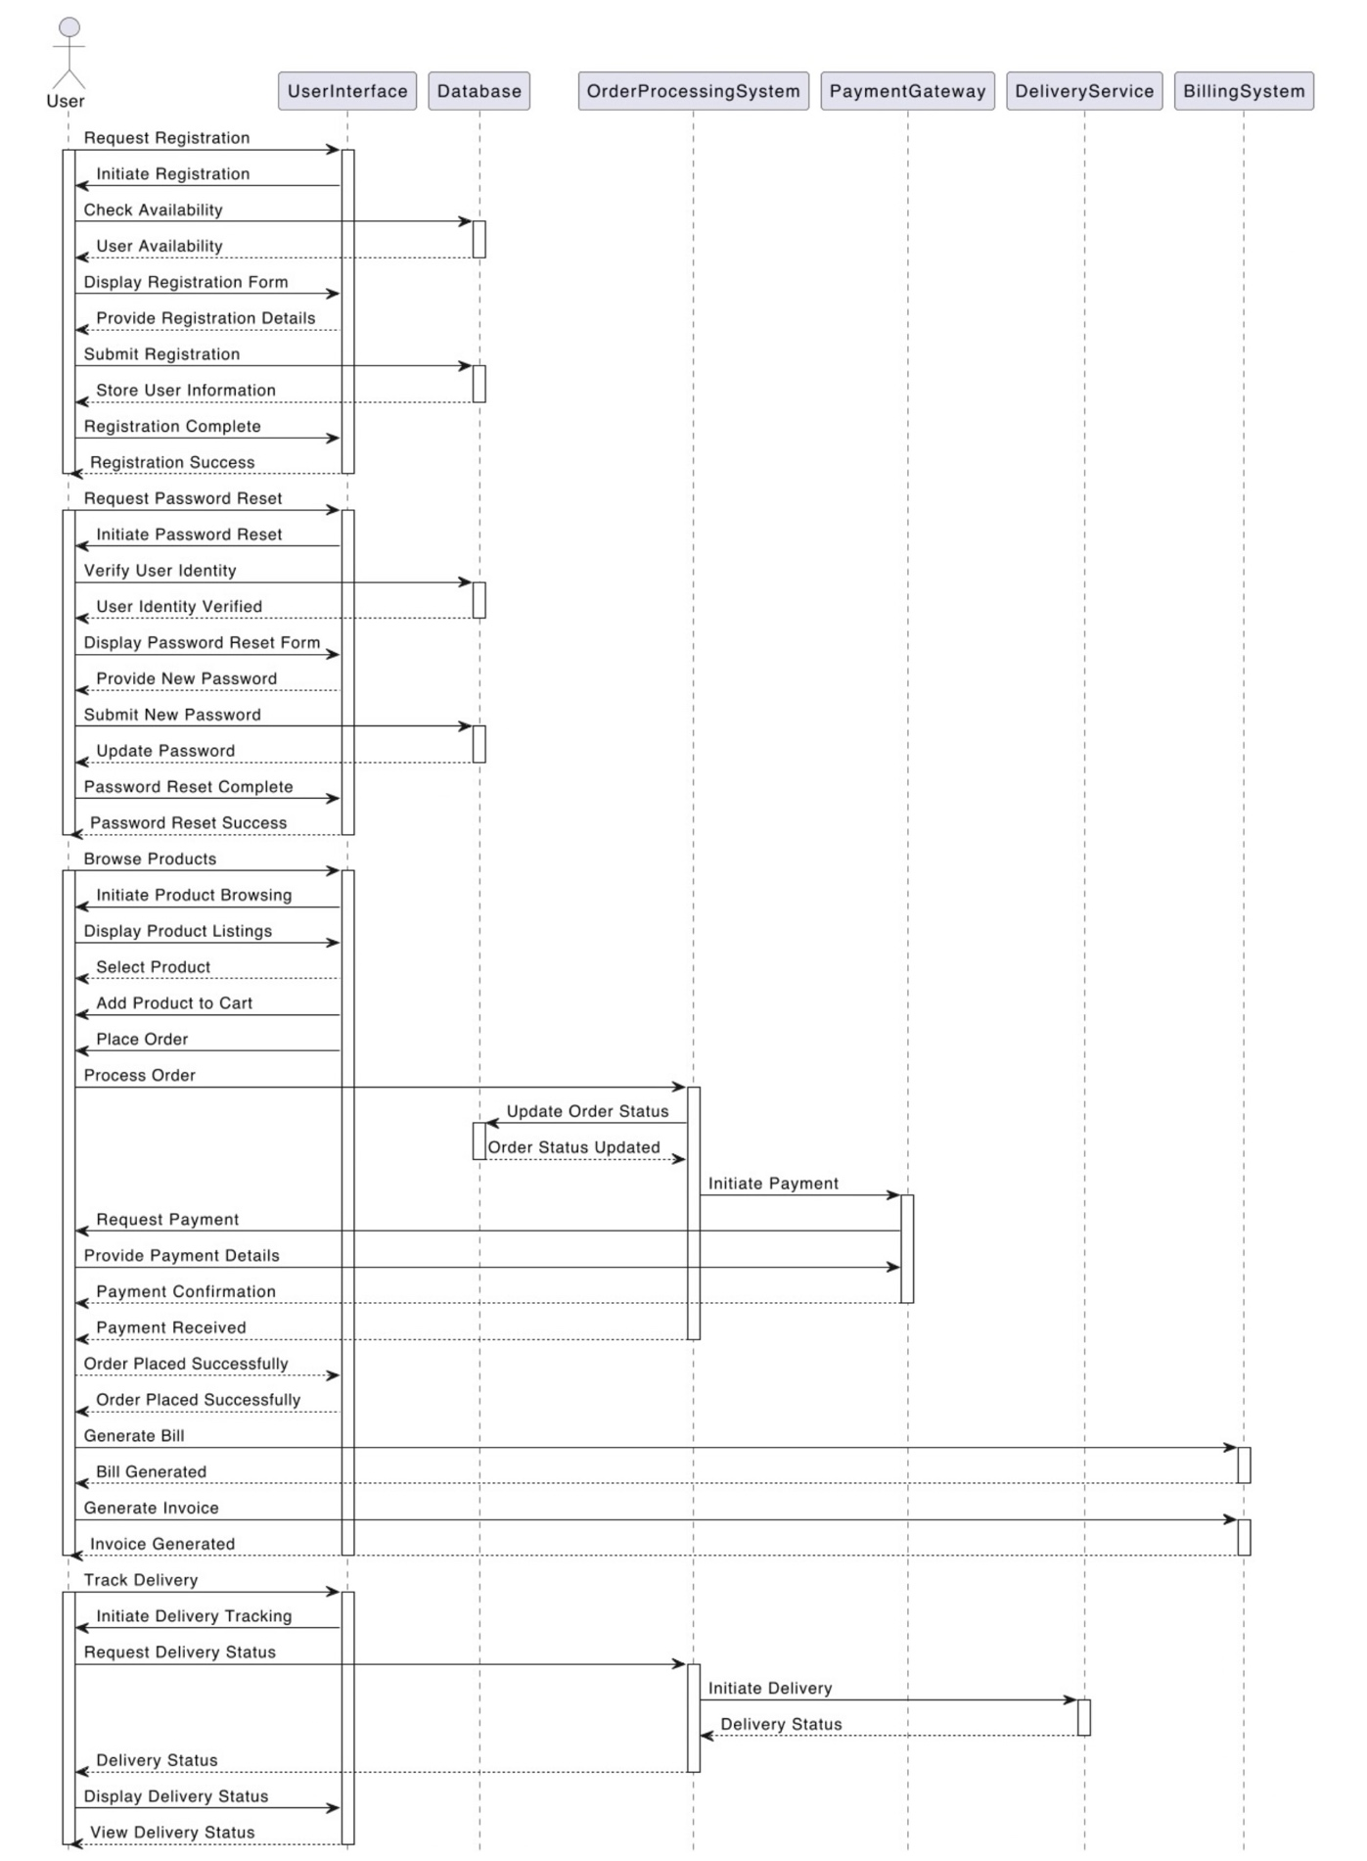

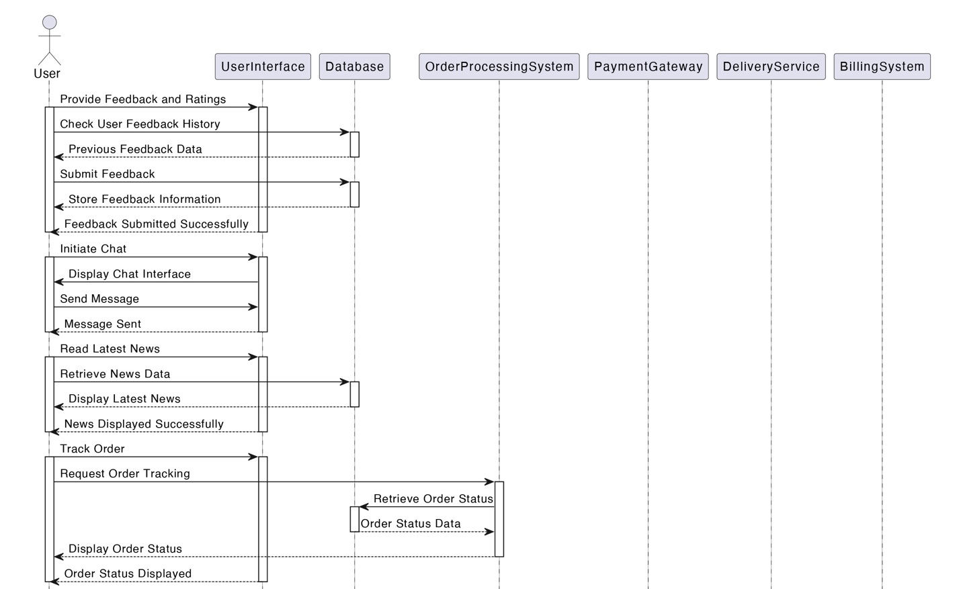

1. **State Chart Diagram**

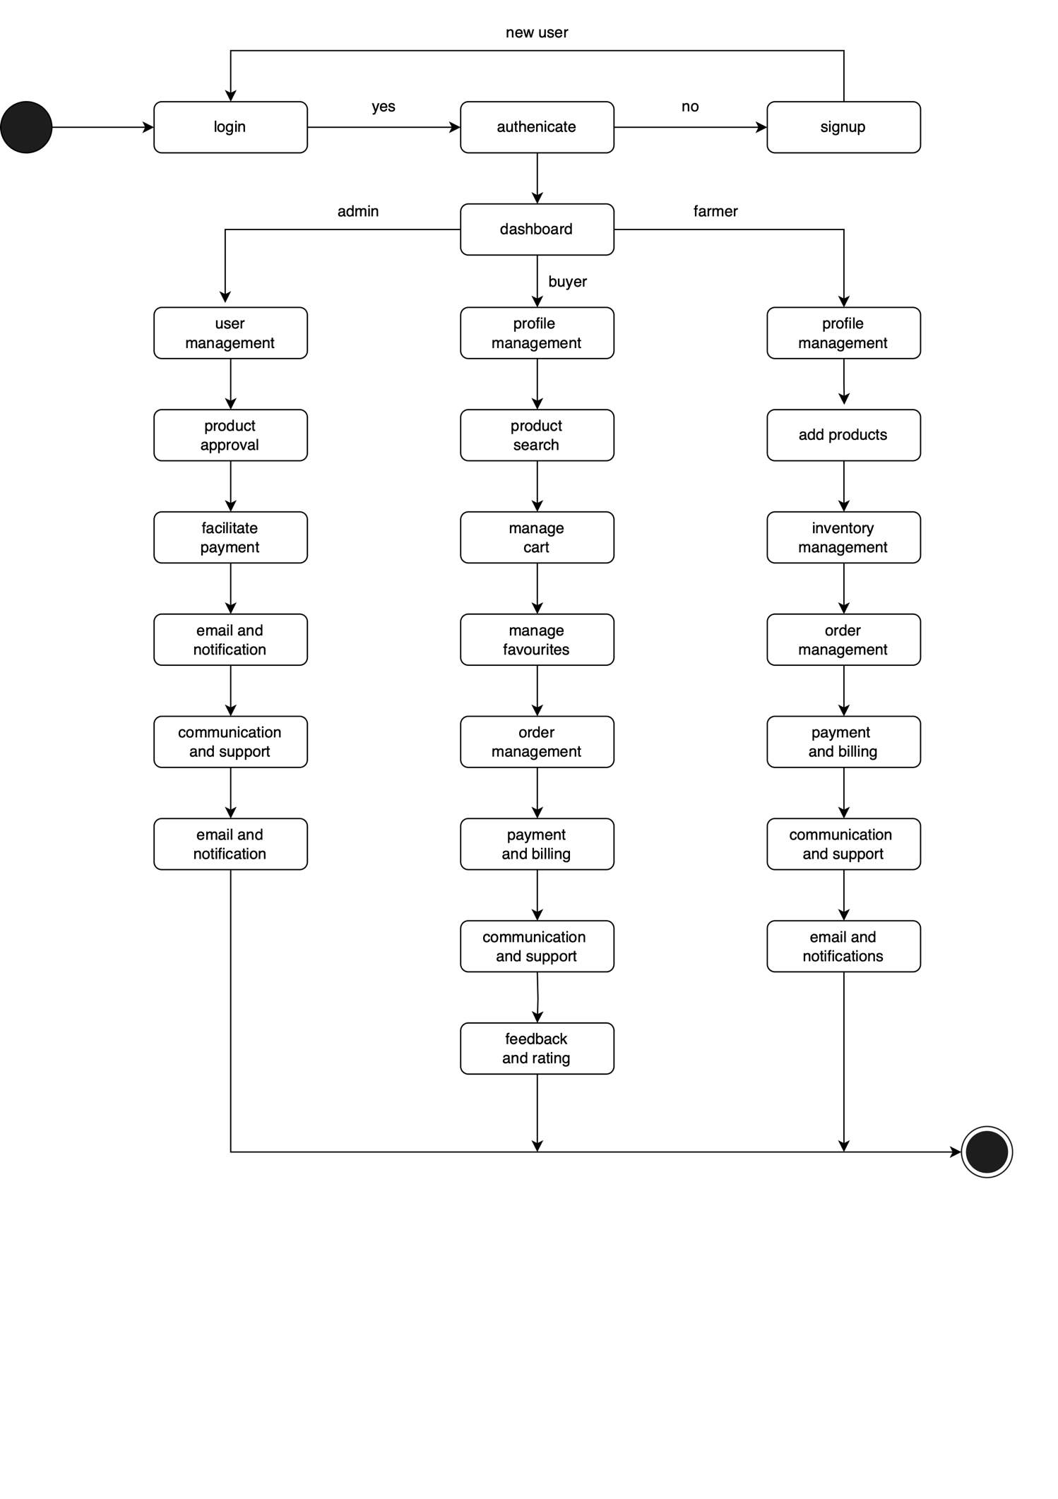

1. **Component Diagram**

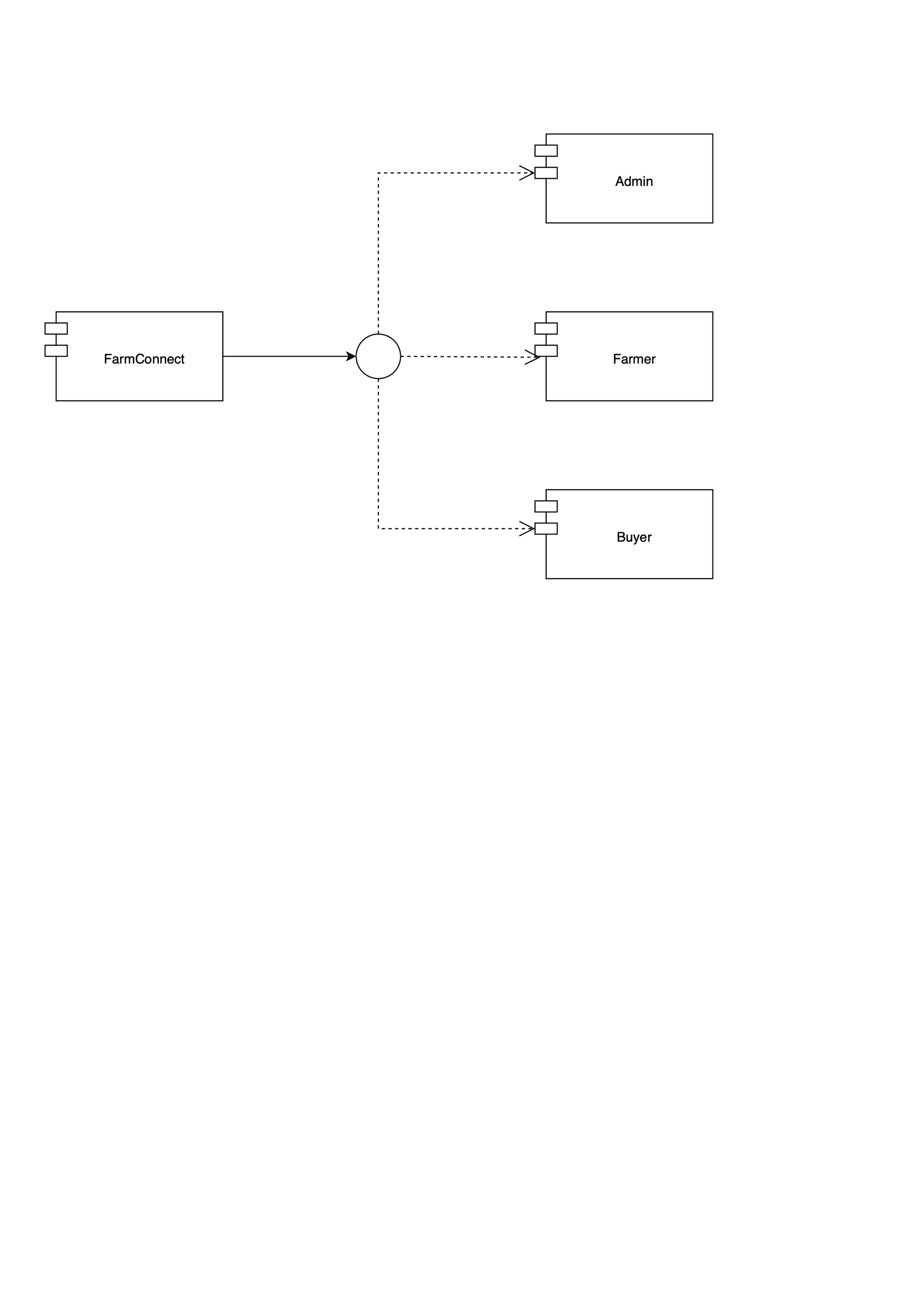

1. **Deployment Diagram**

